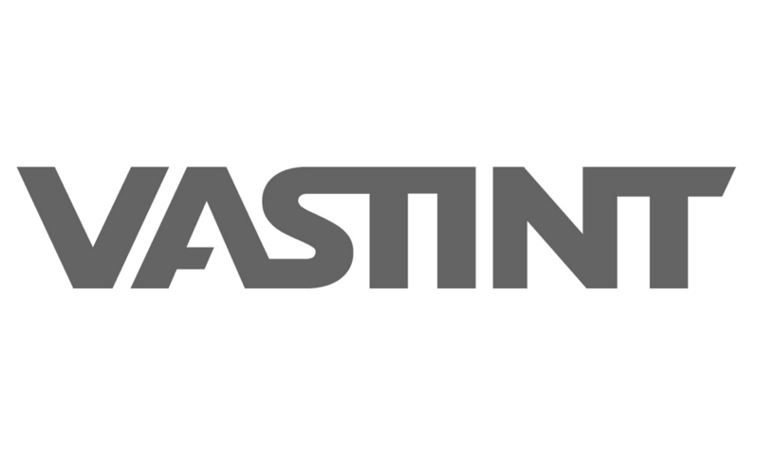
DPA PROCEDURE AT VASTINT
Data Processing Agreement workflow

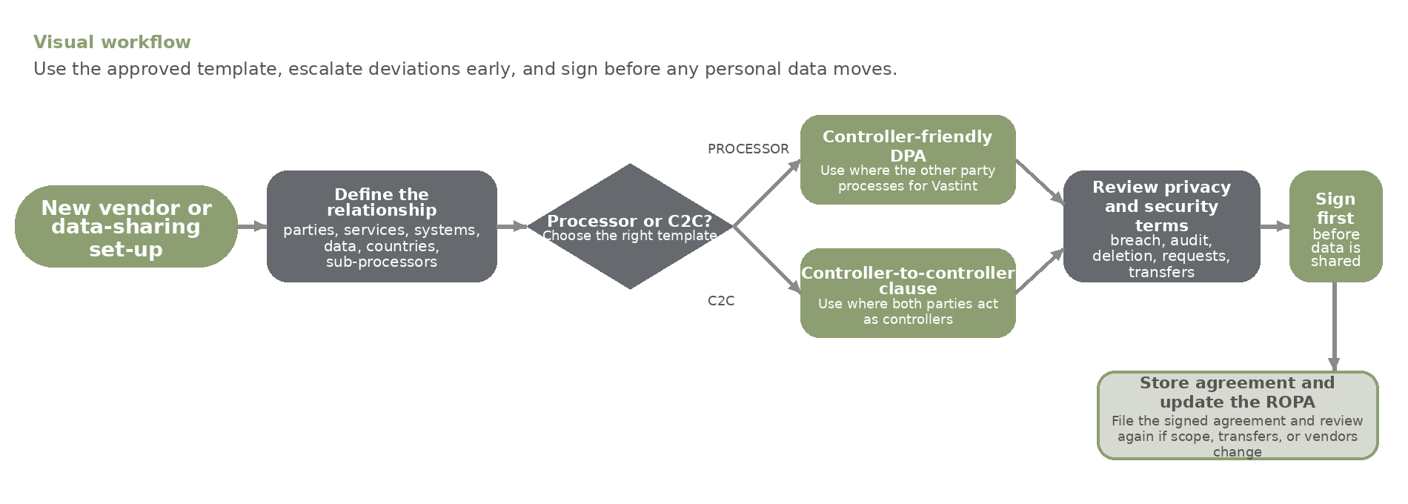
When to start  • New vendor, supplier, service, or group arrangement will handle personal data for Vastint.  • Scope, countries, sub-processors, security set-up, or data flows materially change.  • Do not start sharing personal data before the right agreement is signed. | Review checklist  • Check the role split, instructions, deletion/return, audit rights, and breach wording.  • Confirm security measures, transfer terms, and support for data subject requests.  • Escalate material deviations from the approved template before signature. | Templates, legal and filing  Use the approved DPA or C2C template:  Teams > Privacy Champions Team > General > Privacy & Procedures Templates  File signed agreements in Data Processing Agreements Folder.  Questions?  privacy@vastint.eu / lucas.noronha@vastint.eu

